Physics Stage 3: STAWA Set 3 Answers

1 The hammer is released when the thrower is facing South or North depending on whether he is rotating clockwise or anticlockwise respectively.

When release at these positions the tangential velocity is due west and in the absence of the centripetal force supplied by the thrower the hammer will continue in this direction.

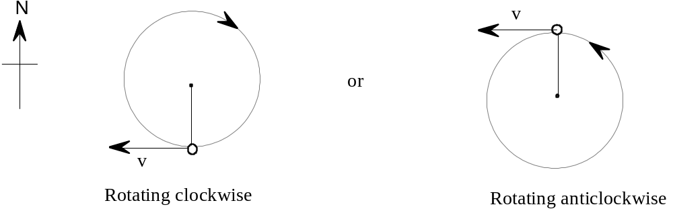

2 When a runner leans over to round a bend the reaction force also leans in the same direction. The component of the reaction directed towards the centre of the curve supplies the centripetal force.

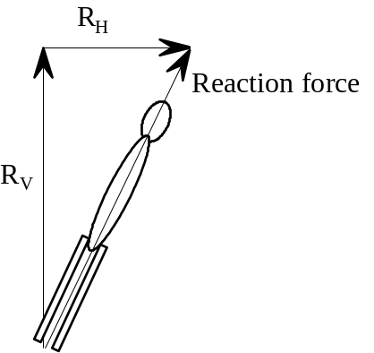 | That is  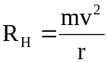

3 The reaction to the frictional force between the ground and the wheels of the roller skates.

4
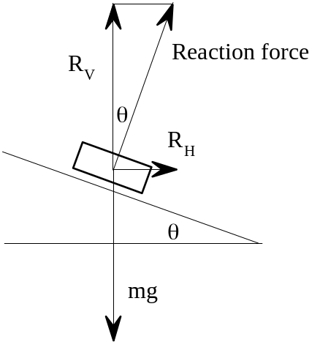 | RV = mg  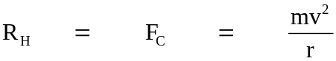  This relationship is true if the angle is appropriate for the speed of the vehicle and the radius of curvature.  ie 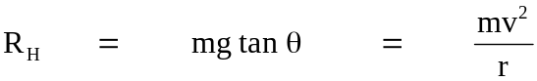

5
r = 15 m  v = 3.5 m s-1 | 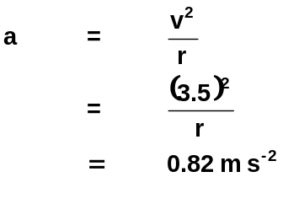
The acceleration is 0.82 m s -2 towards the centre of the curve

6
m = 0.585 kg  r = 1.25 m  v = 11.5 m s-1  F = ? | 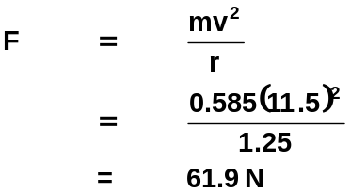
The force to hold bat = 61.9 N

7a
T = 15.5 s  r = 3.80 m | 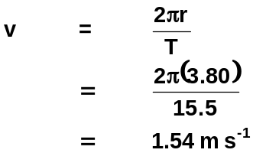
The speed of child = 1.54 m s-1
b
m = 28.0 kg  v = 1.54 m s-1  r = 3.80 m | 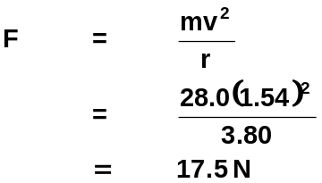
The centripetal force on child = 17.5 N

8
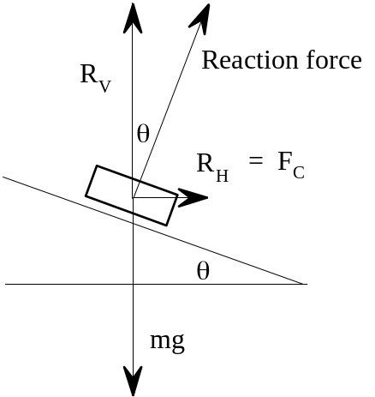 | 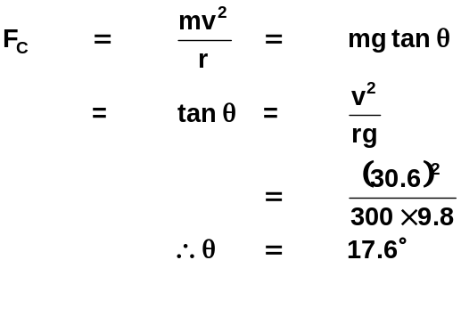

9
a. m = 55 kg  r = 2.50 m  L = 4.00 m  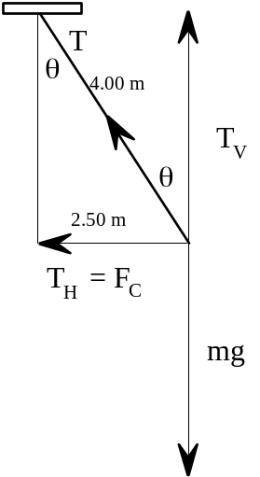 | 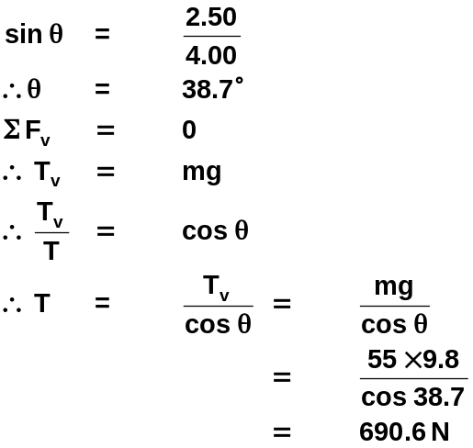  The tension is 691 N

b. sin 38.7 =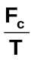 F_{c} = 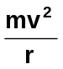
F_{c} = T sin 38.7 v = 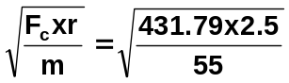
= 690.6 sin 38.7 v = 4.43 ms⁻¹
= 431.79 N
T = 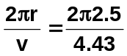
T = 3.55 s

10

- Yes. the car is constantly changing its velocity as the direction is changing as it goes around the circular path. As the change in velocity occurs over a change in time, then the car is accelerating as acceleration is rate of change of velocity.

m = 1250 kg 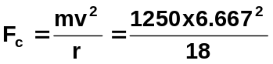
r = 18.0 m F_{c} = 3086 N
v = 24.0 ms⁻¹ = 3.09 x 10³ N
= 6.667 ms⁻¹
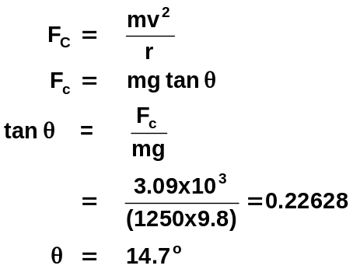
c. v = 6.667 ms⁻¹
g = 9.8 ms⁻²
r = 18.0 m

11. r = 70 m tan θ = 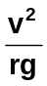
angle = 20⁰ tan 20 = 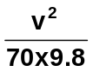
v = ? v² = 249.68
v = 15.8 ms⁻¹

12.

a.
3800 rev = 60 s 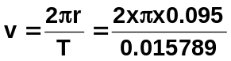
1 rev = 60/3800 v = 37.8 ms⁻¹
T = 0.015789 s
r = 0.095 m

b. v = 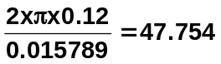ms⁻¹ a_{c} = 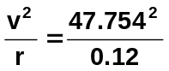
a_{c} = 19003
a_{c} = 1.90 x 10⁴ ms⁻¹

c. m = 9.8 x 10⁻¹² kg
break if greater than 8.2 x 10⁻³ N f = 
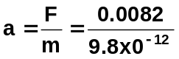
a = 8.3673 x 10⁸ ms⁻¹

a = 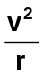
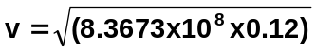
v = 10020 ms⁻¹

T = 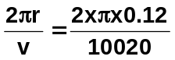
T = 7.52448 x 10⁻⁵

f = 1/7.5248 x 10⁻⁵

f = 1.33 x 10⁴ Hz
(STAWA answer 17.7 kHz)

13.
a. Force is centripetal force which acts towards the centre.

b. v = 7.8 x 10⁶ ms⁻¹ 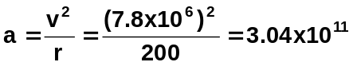
r = 200 m F = ma = 1.7 x 10⁻²⁷ x 3.04 x 10¹¹
m = 1.7 x 10⁻²⁷ kg F = 5.17 x 10⁻¹⁶ N
(NB: STAWA answer used r = 400 m instead of the correct 200 m)

c.
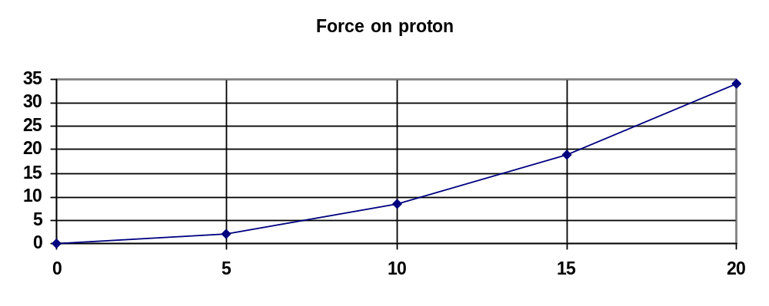
Force (x 10⁻¹⁶) N
speed (x 10⁶) ms⁻¹

d. times differ but not used in this answer circumference = π x diam
= 400π
does this 440 000 times
= 440 000 x 400 x π
= 5.53 x 10⁸ m

e. using t = 2.5 s s_{v} = u_{v}t + ½ gt²
g = 9.8 ms⁻¹ down = 0 + (4.9 x 2.5²)
u_{v} = 0 = 30.6 m
so protons drop 30.6 m below release point

f. Some way to stop the protons from dropping e.g. magnets or magnetic field to keep them in a horizontal position

